|  |  |  |  |  |  |  |
| --- | --- | --- | --- | --- | --- | --- |
| |  |  |  |  | | --- | --- | --- | --- | |  | | **MINISTRY OF EDUCATION AND TRAINING** | | | **FPT UNIVERSITY** | | |
| Capstone Project Document |
| Online Medical Consultant System |
| |  |  |  |  |  |  |  |  |  |  |  | | --- | --- | --- | --- | --- | --- | --- | --- | --- | --- | --- | | |  |  | | --- | --- | | **Group 02** | | | **Group member** | Trần Nguyên Tiến Sứ - Team Leader - SE60781  Trần Cao Danh - Team Member - SE60705 | | **Supervisor** | Mr. Nguyễn Huy Hùng | | **Ext. Supervisor** | N/A | | **Capstone Project code** | OMCS | | |
| * Ho Chi Minh City, 07/2014 – |

# Table of Content

Table of Content 2

List of Figures 3

Definitions, Acronyms, and Abbreviations 4

Report No.4 Software Design Description 5

1. Design Overview 5

2. System Architectural Design 6

3. Component Diagram 7

4. Detailed Description of Components 8

# List of Figures

Figure 1: MVC Architecture 6

Figure 2 Component Diagram 7

Figure 3: Class Diagram 8

Figure 4: Define new medical profile template 9

Figure 5 Doctor Update Medical Profile 9

Figure 6 Patient update Personal Health Record 10

Figure 7 Doctor view Medical Profile Record 10

Figure 8 Patient view Medical Profile Record 11

# Definitions, Acronyms, and Abbreviations

|  |  |
| --- | --- |
| OMCS | Online Medical Consultant System |

# Report No.4 Software Design Description

## Design Overview

* This document describes the technical and user interface design of. It includes the architectural design, the detailed design of common functions and business functions and the design of database model.
* The architectural design describes the overall architecture of the system and the architecture of each main component.
* The detailed design describes static and dynamic structure for each component and functions. It includes class diagrams, class explanations and sequence diagrams for each use cases.
* The database design describes the relationships between entities and details of each entity.

## System Architectural Design

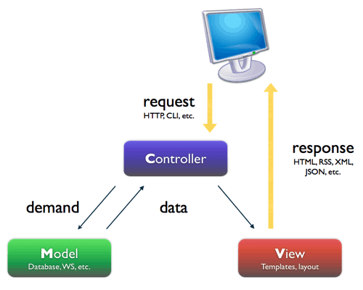

Figure : MVC Architecture

**(http://smist08.wordpress.com/tag/mvc/)**

**The Model** is the part of the application that handles the logic for the application data.  
Often model objects retrieve data (and store data) from a database.

**The View** is the parts of the application that handles the display of the data.  
Most often the views are created from the model data.

**The Controller** is the part of the application that handles user interaction.  
Typically controllers read data from a view, control user input, and send input data to the model.

**(**[**http://www.w3schools.com/aspnet/mvc_intro.asp**](http://www.w3schools.com/aspnet/mvc_intro.asp)**)**

## Component Diagram

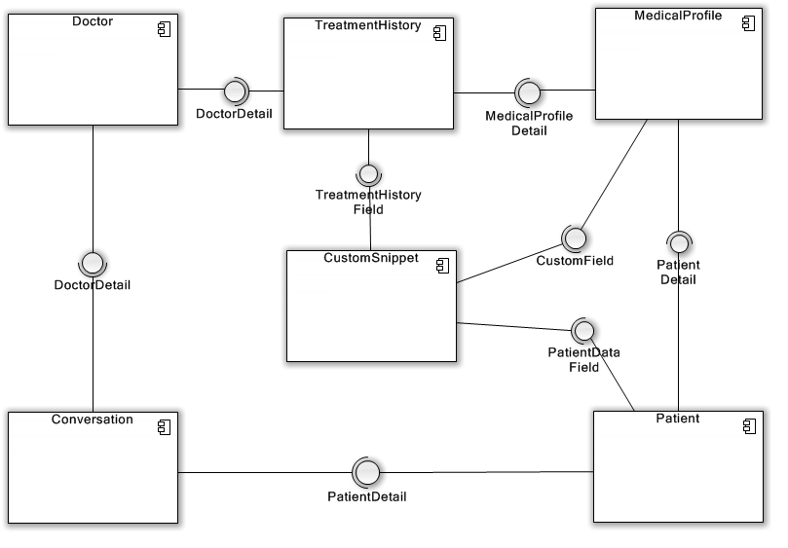

Figure Component Diagram

## Detailed Description of Components

* 1. Class Diagram

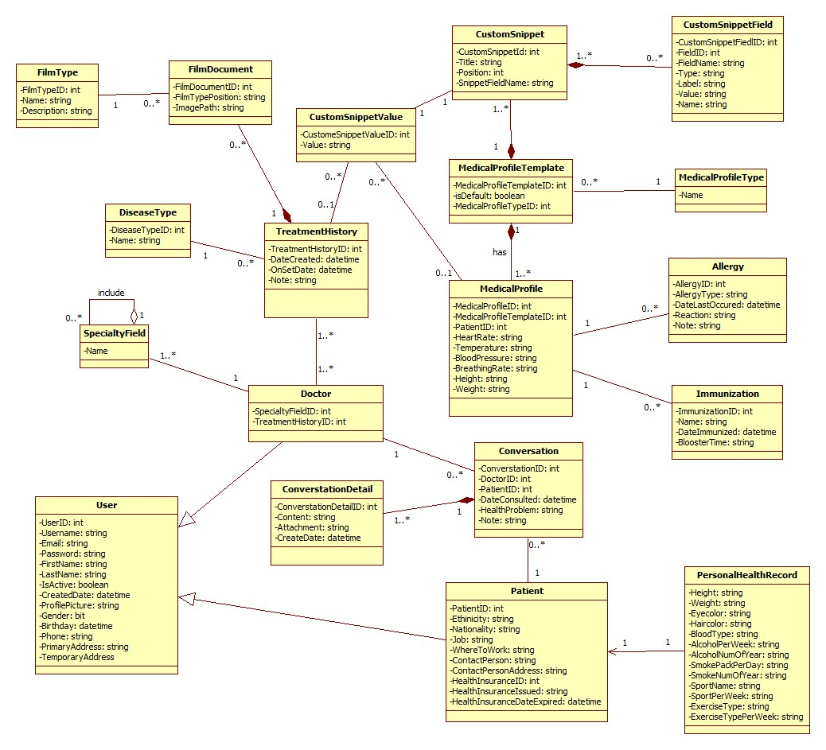

Figure 3: Class Diagram

* 1. Sequence Diagram
     1. Admin define new Medical Profile template

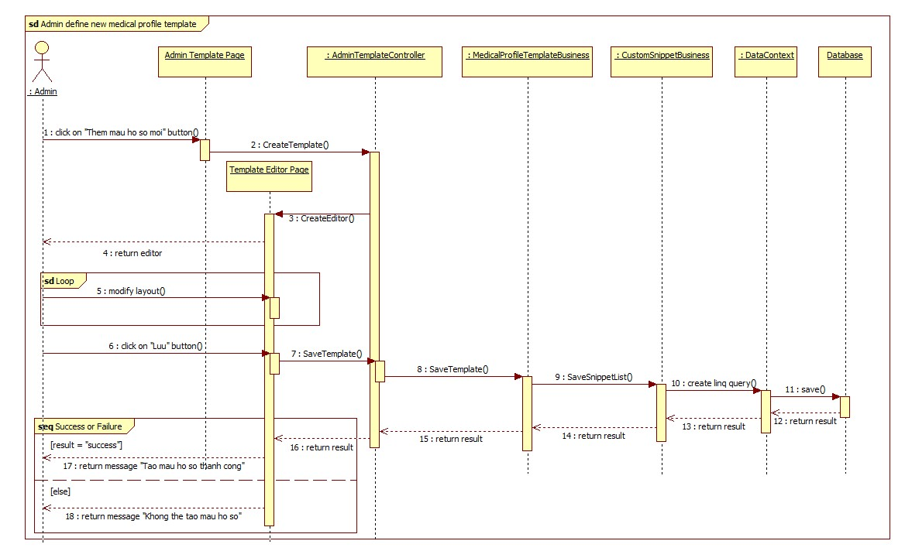

Figure 4: Define new medical profile template

* + 1. Admin update medical profile template

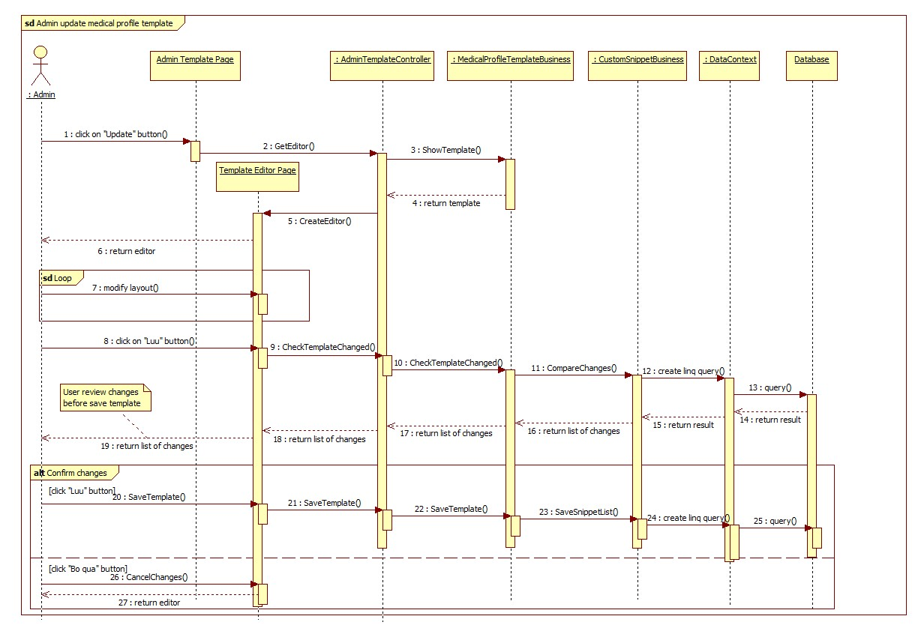

* + 1. Doctor Update Medical Profile

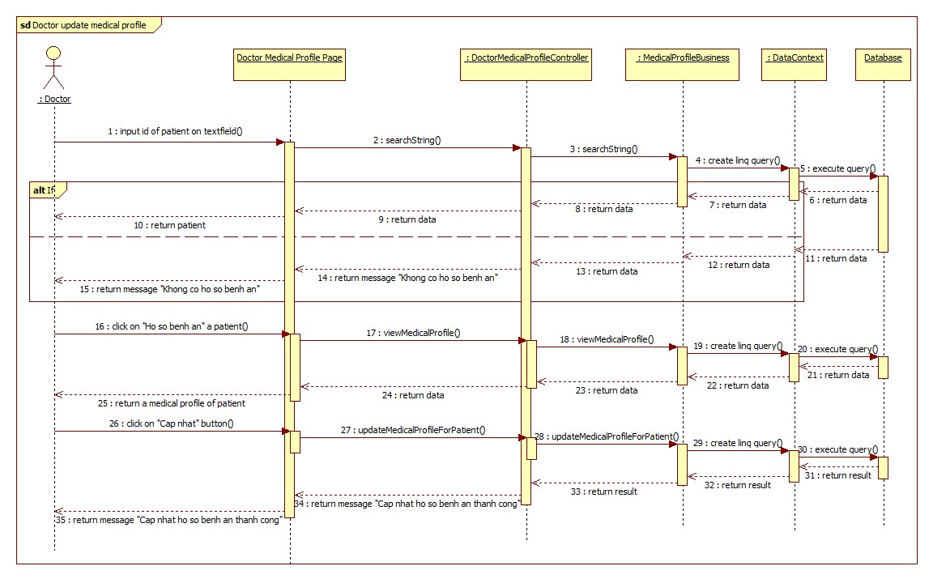

Figure Doctor Update Medical Profile

* + 1. Patient update Personal Health Record

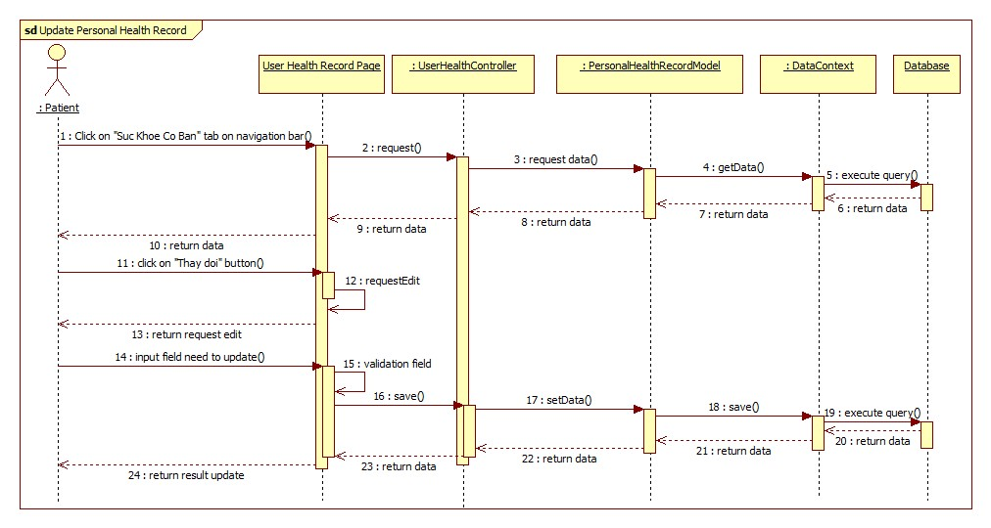

Figure Patient Update Personal Health Record

* + 1. Doctor view Medical Profile Record

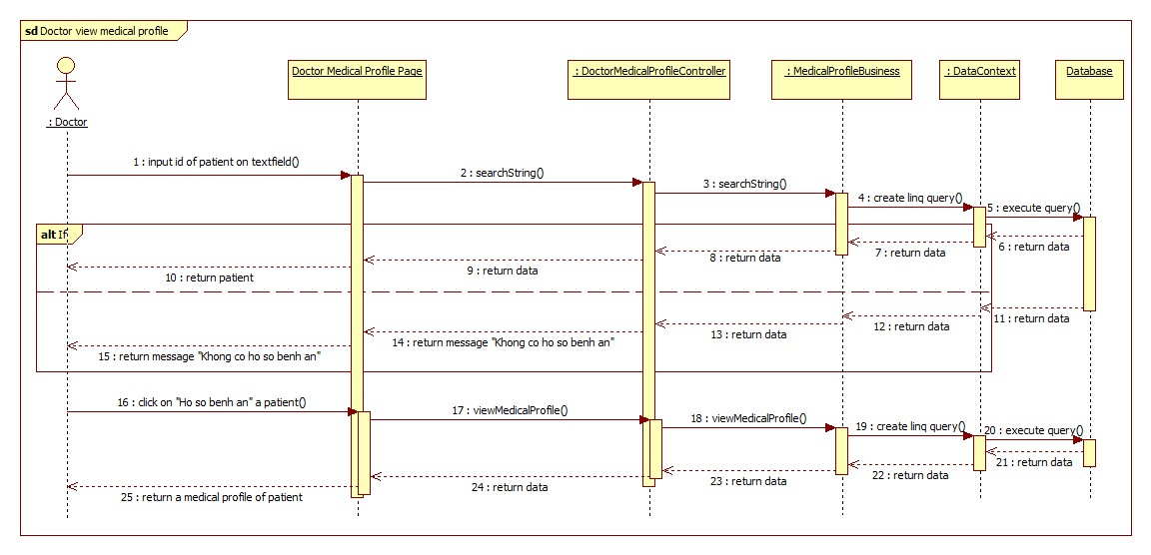

Figure Doctor View Medical Profile Record

* + 1. Patient Conversation

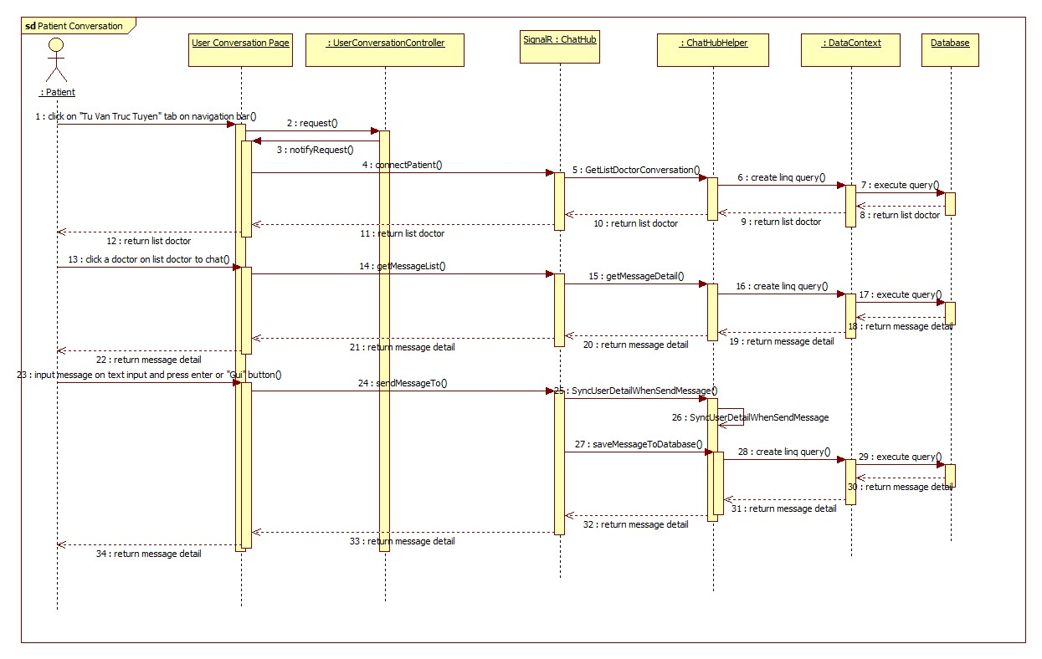

Figure 8 Patient View Medical Profile Record

* + 1. Patient view medical Profile Record

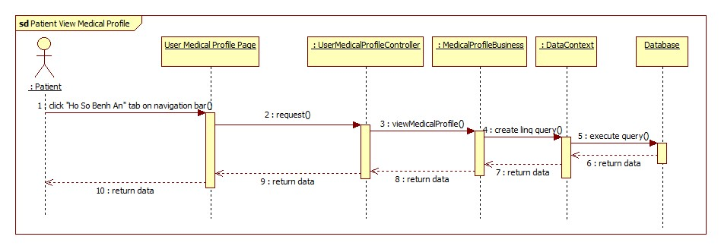

Figure 9 Patient View Medical Profile Record